Sleep management

Introduction

Project description

Background- The project was initially made for AUA students who cannot manage their sleep schedule good enough to meet their other requirements. The objective of the system is to remind the user of when they have to go to sleep and wake up.

Assumptions and constraints- The program should be made by the end of the month in order to help AUA students manage their working- resting schedule in the most effective way, and be able to use it starting from the ongoing semester. The students are chosen as a target group, as they have most issues with sleep management according to recent survey.

Overview of the envisioned system

Overview and System scope- The students will be separated to groups according to the amount of classes they have and the amount of time they spend on classes and sleep daily, as they will select options for those in the beginning. After that the program will give out the most optimal schedule for each student. Options selected can be updated.

|  |  |
| --- | --- |
| Select the option that suits you best | Select the option that suits you best |
| Sleep amount 4-6 hours | Work amount 10-12 hours |
| Sleep amount 6-8 hours | Work amount 12-14 hours |
| Sleep amount 8-10 hours | Work amount 14-16 hours |

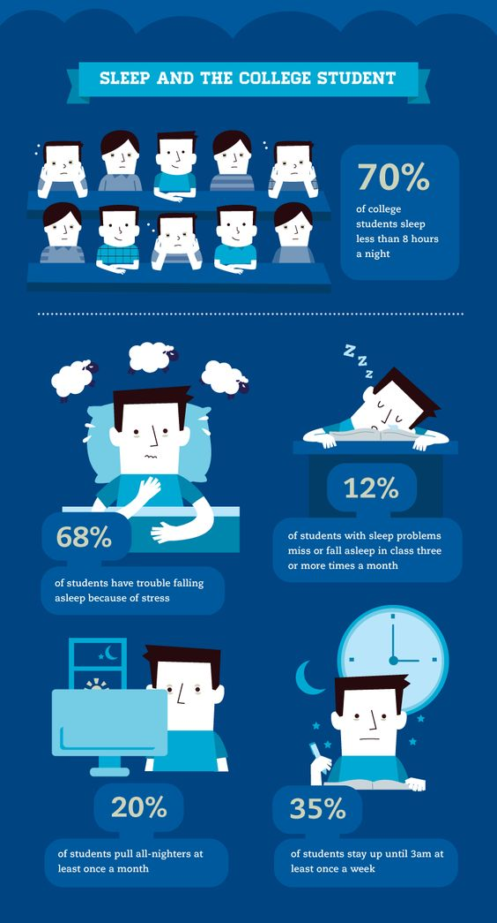

Documents- The customer will receive a schedule option that fits best with the amount of work they usually do, and will receive reminders of when they have to take a rest, like a 15-minute nap, or get to work for a certain amount of time, like 30 minutes or an hour. The initial draft of the project description will be provided by March 2. The other milestones are not yet specified. Time needed will be specified after deadlines are mentioned by the instructor. Initial budget is expected to be an A. In charge of the project are- Edvard Khachiyan, Tigran Kamalian, Davit Petrosian.

Description of envisioned systems

Needs, goals, and objectives of envisioned system- As an output, the program should be able to make each user’s sleeping schedule better and more time- work sufficient. The program will be scanning the options selected by the customer and based on it, will provide the user with an already existing template of a work- sleep schedule, and after asking for permissions, will connect to the device’s internal apps needed, thus sending reminders as sounds and texts.